Quiz 2

What is the output of the following code snippet?

Boolean canine = true, wolf = true;

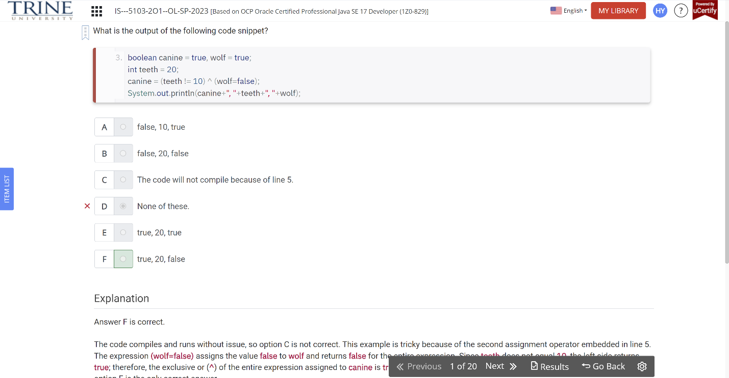

What is the output of the following code snippet?

Int ph = 7, vis = 2;

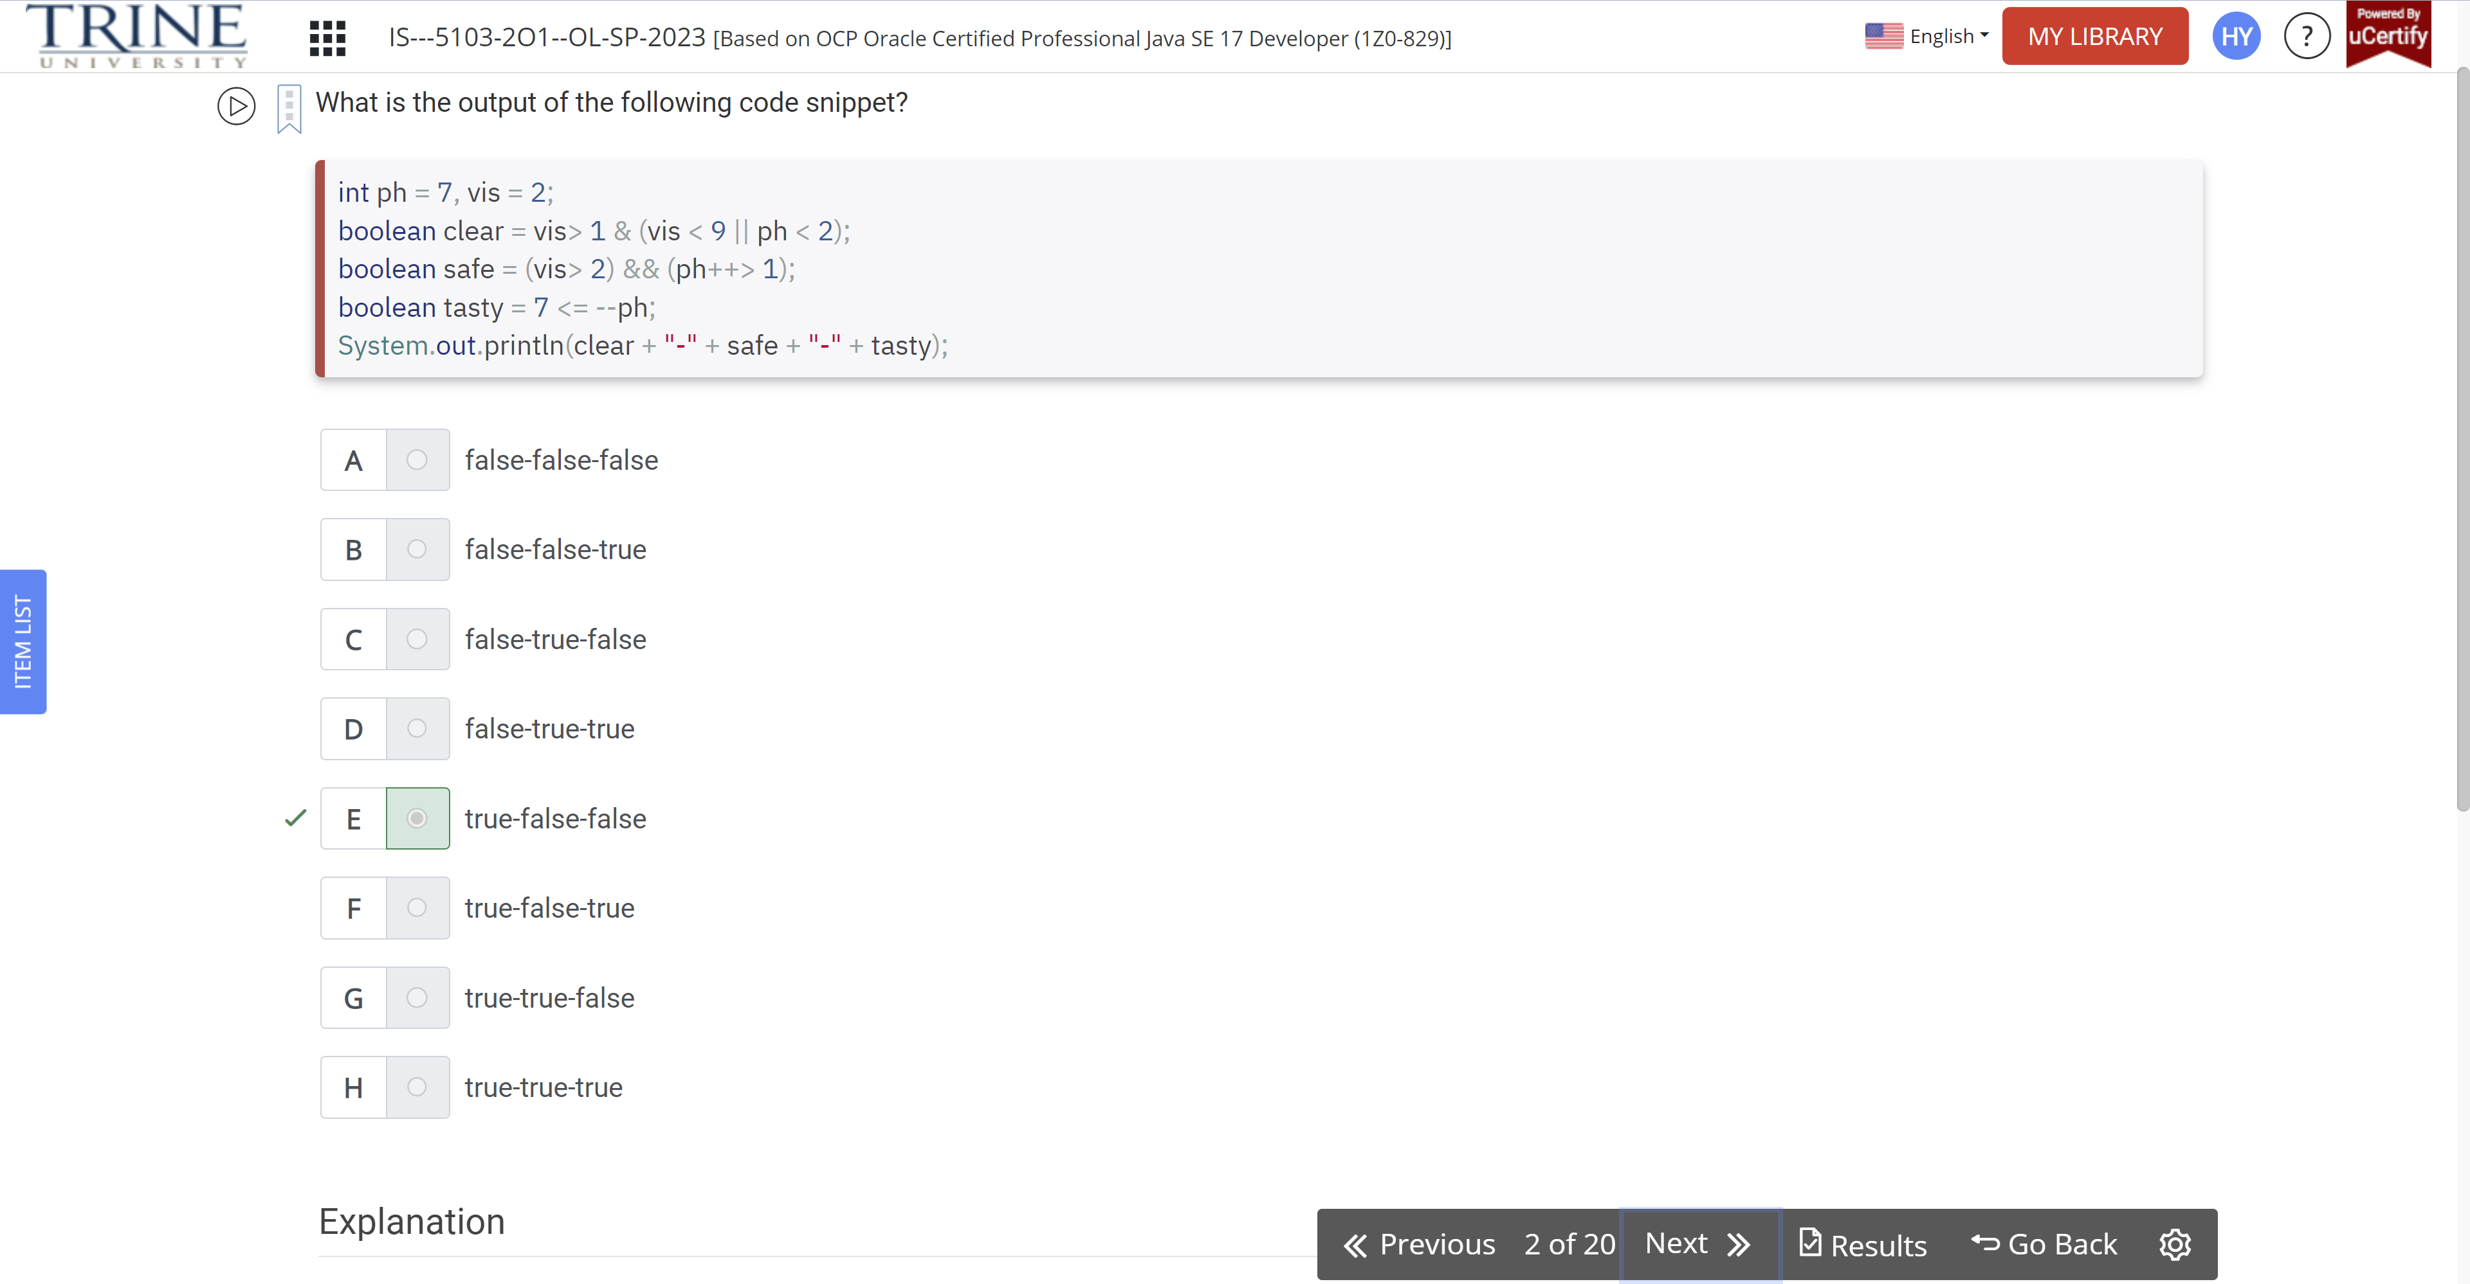

Given the following code snippet, what are the values of the variables after it is executed?

Int ticketsToken = 1;

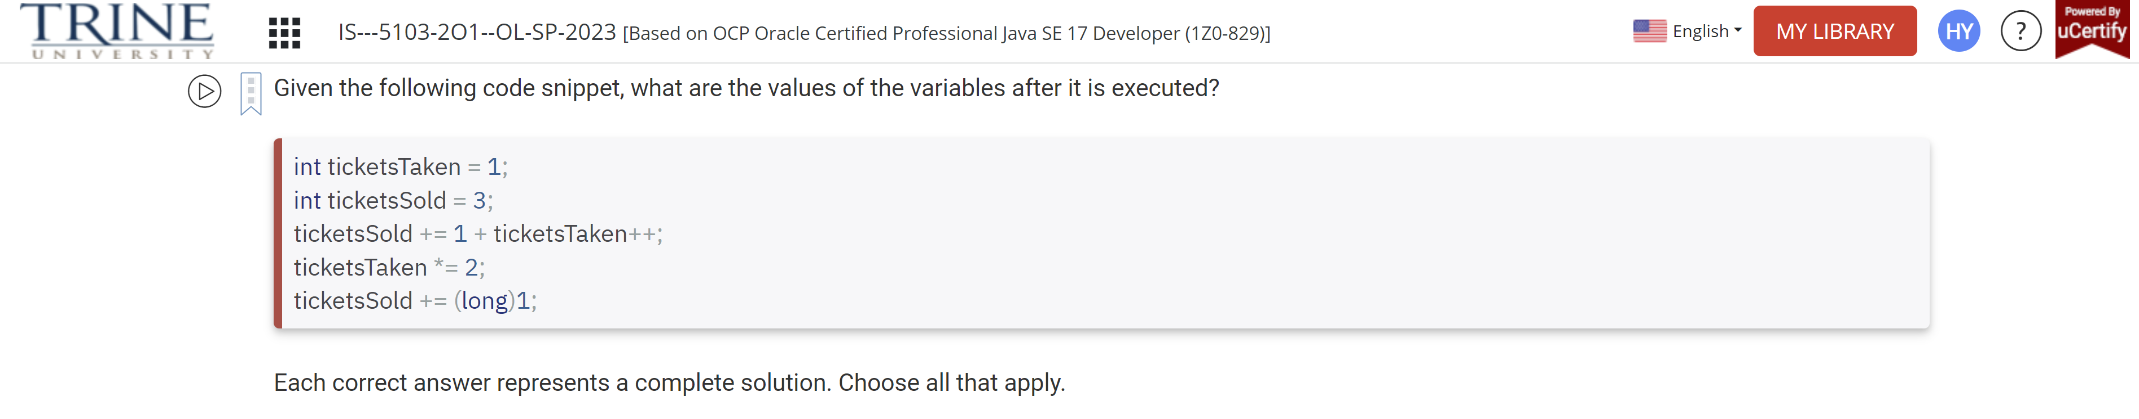

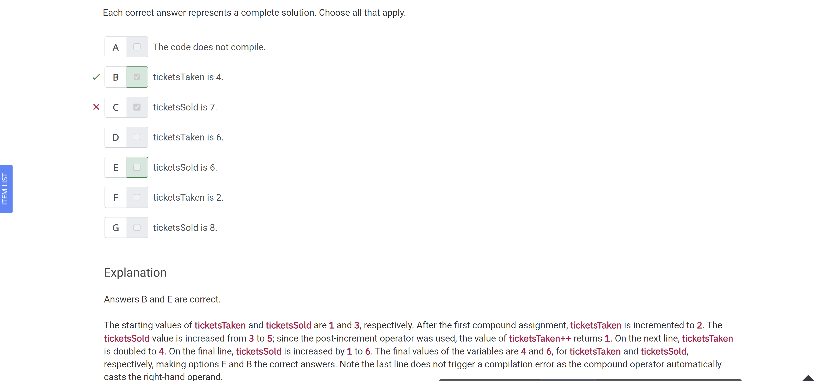

The _ operator increases a value and returns the original value…

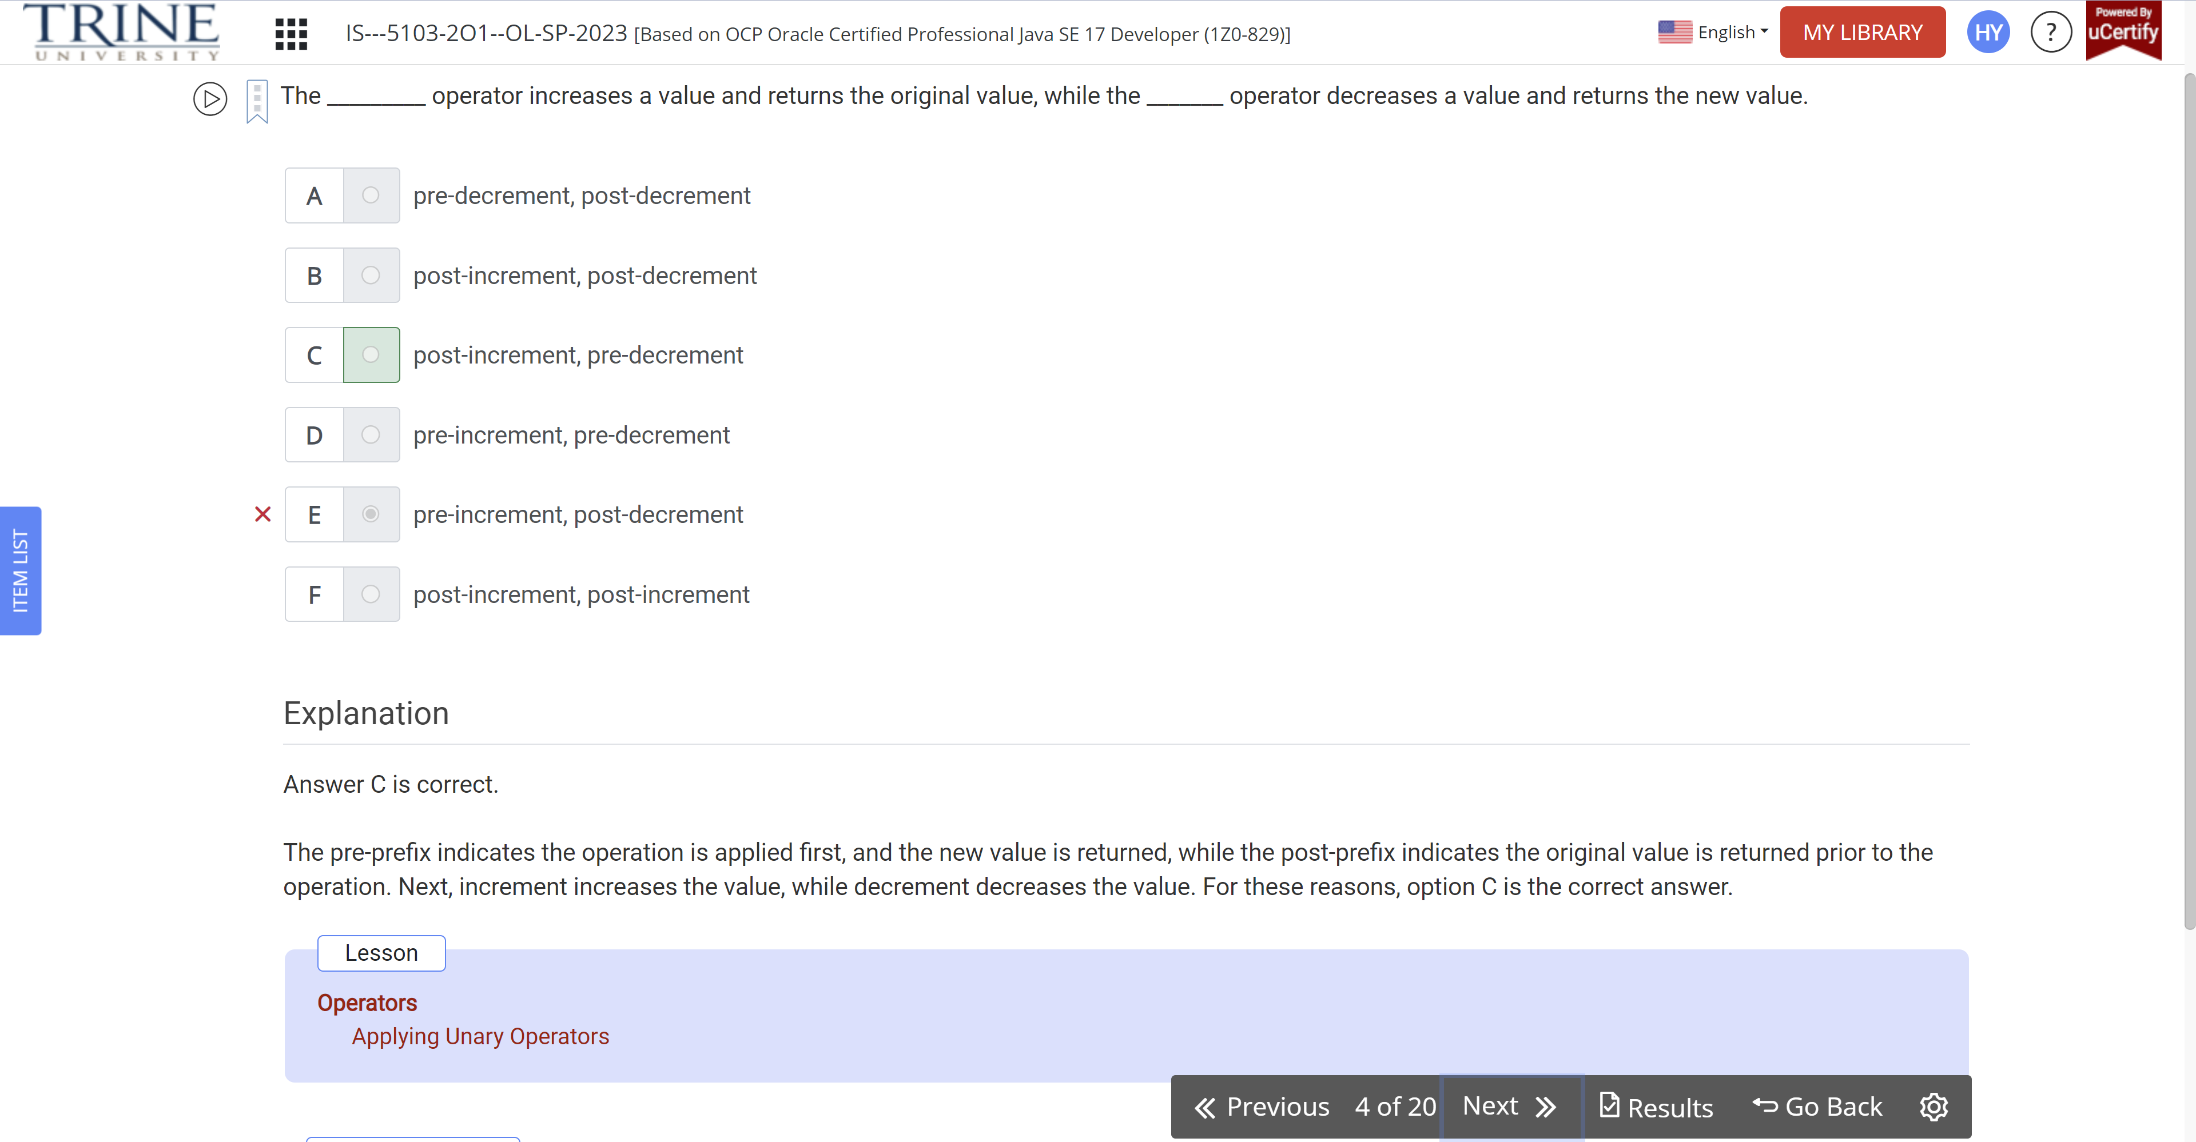

Which of the following Java operators can be used with Boolean variables?

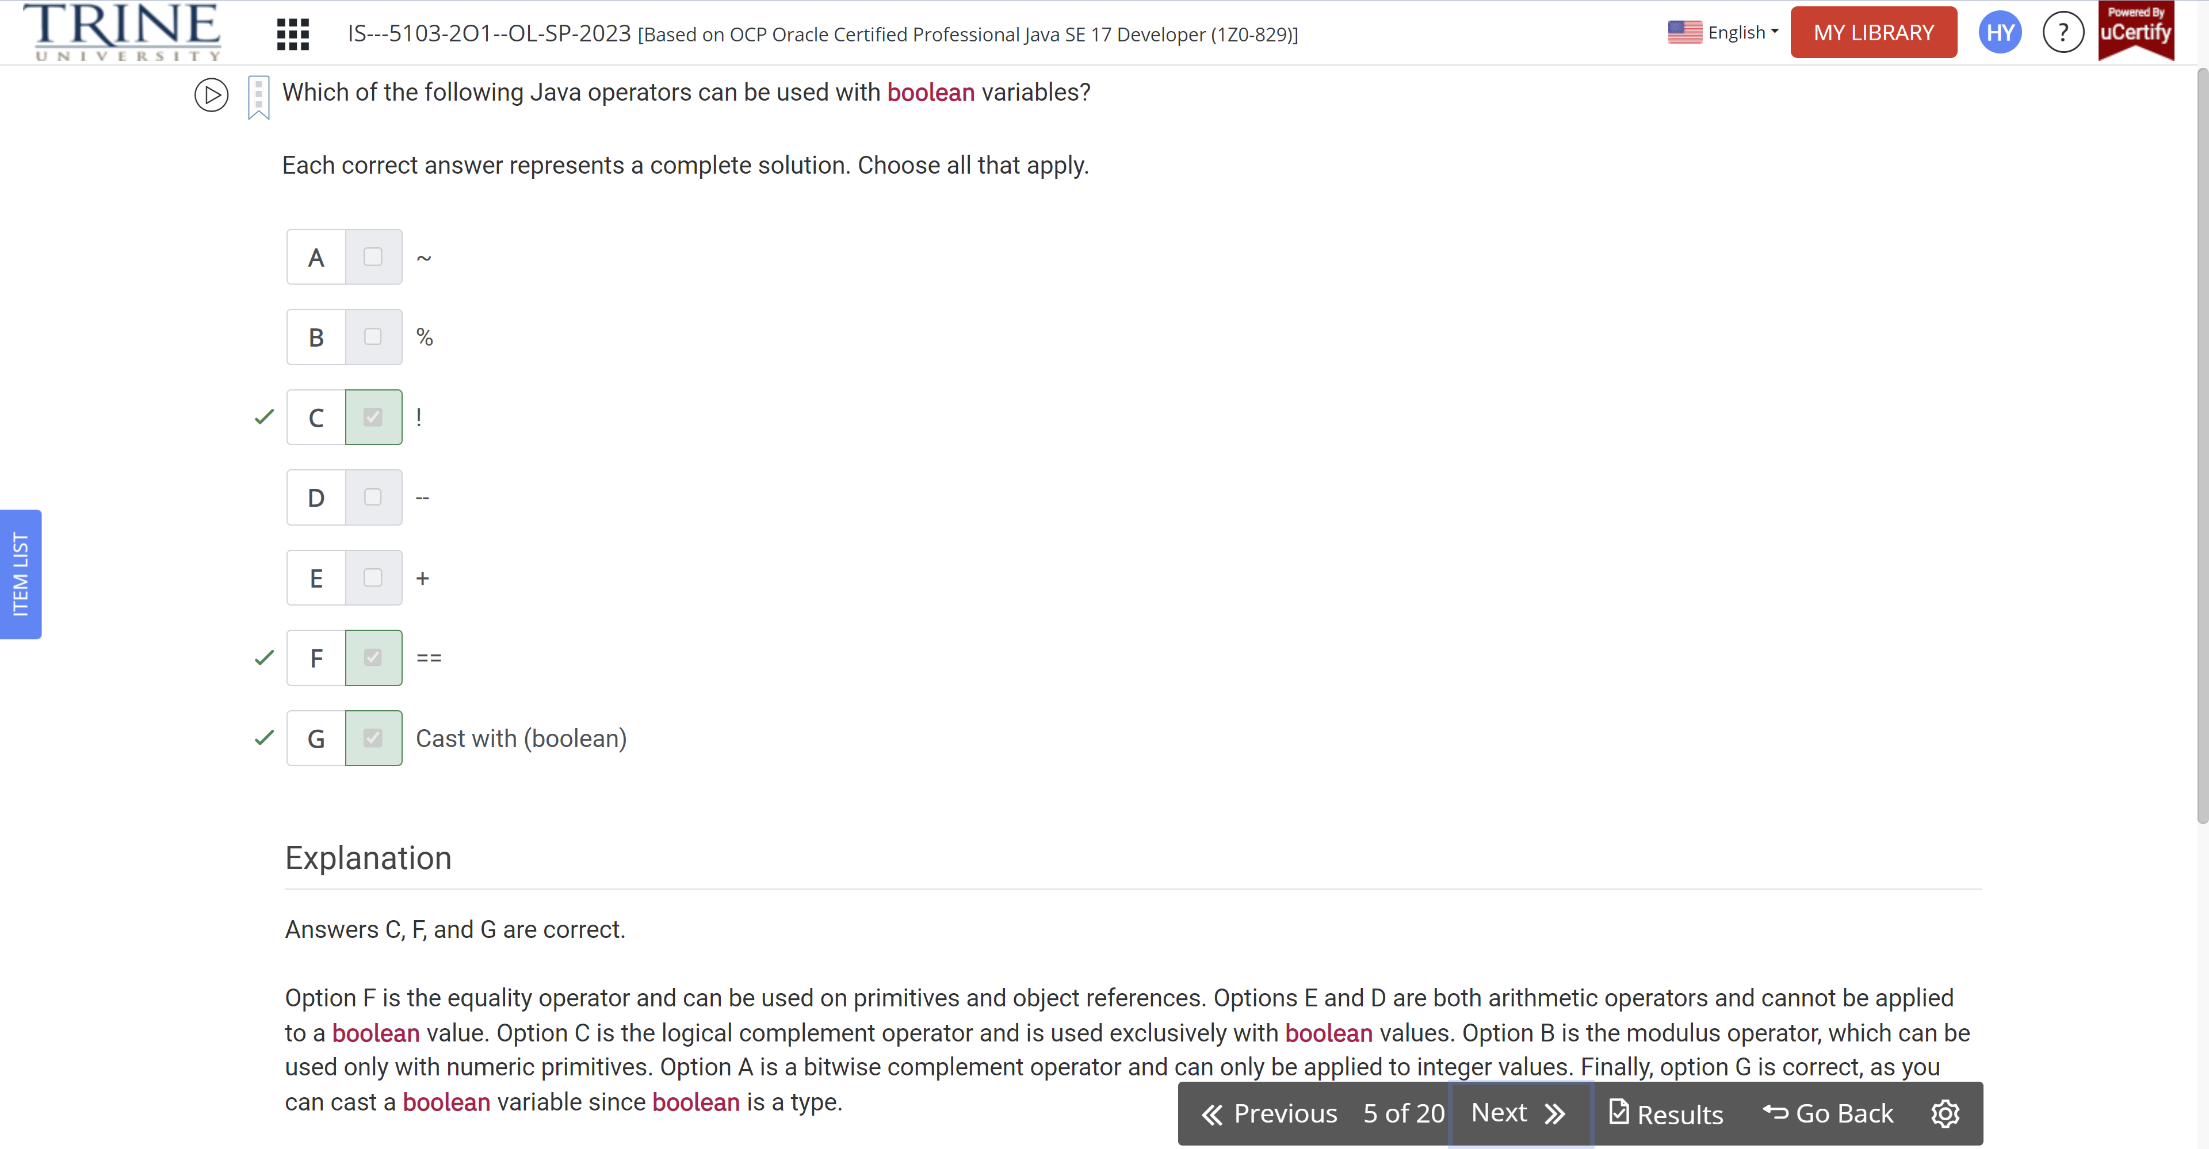

What are the unique outputs of the following code snippet?

Int a = 2, b = 4, c = 2;

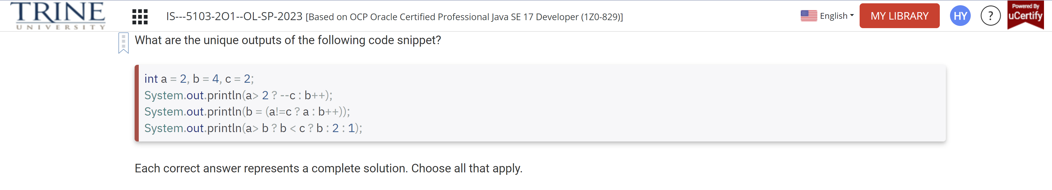

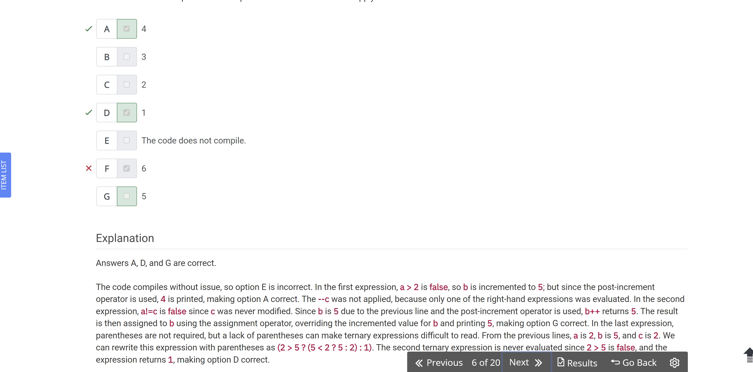

Which of the following statements about unary operators are true?

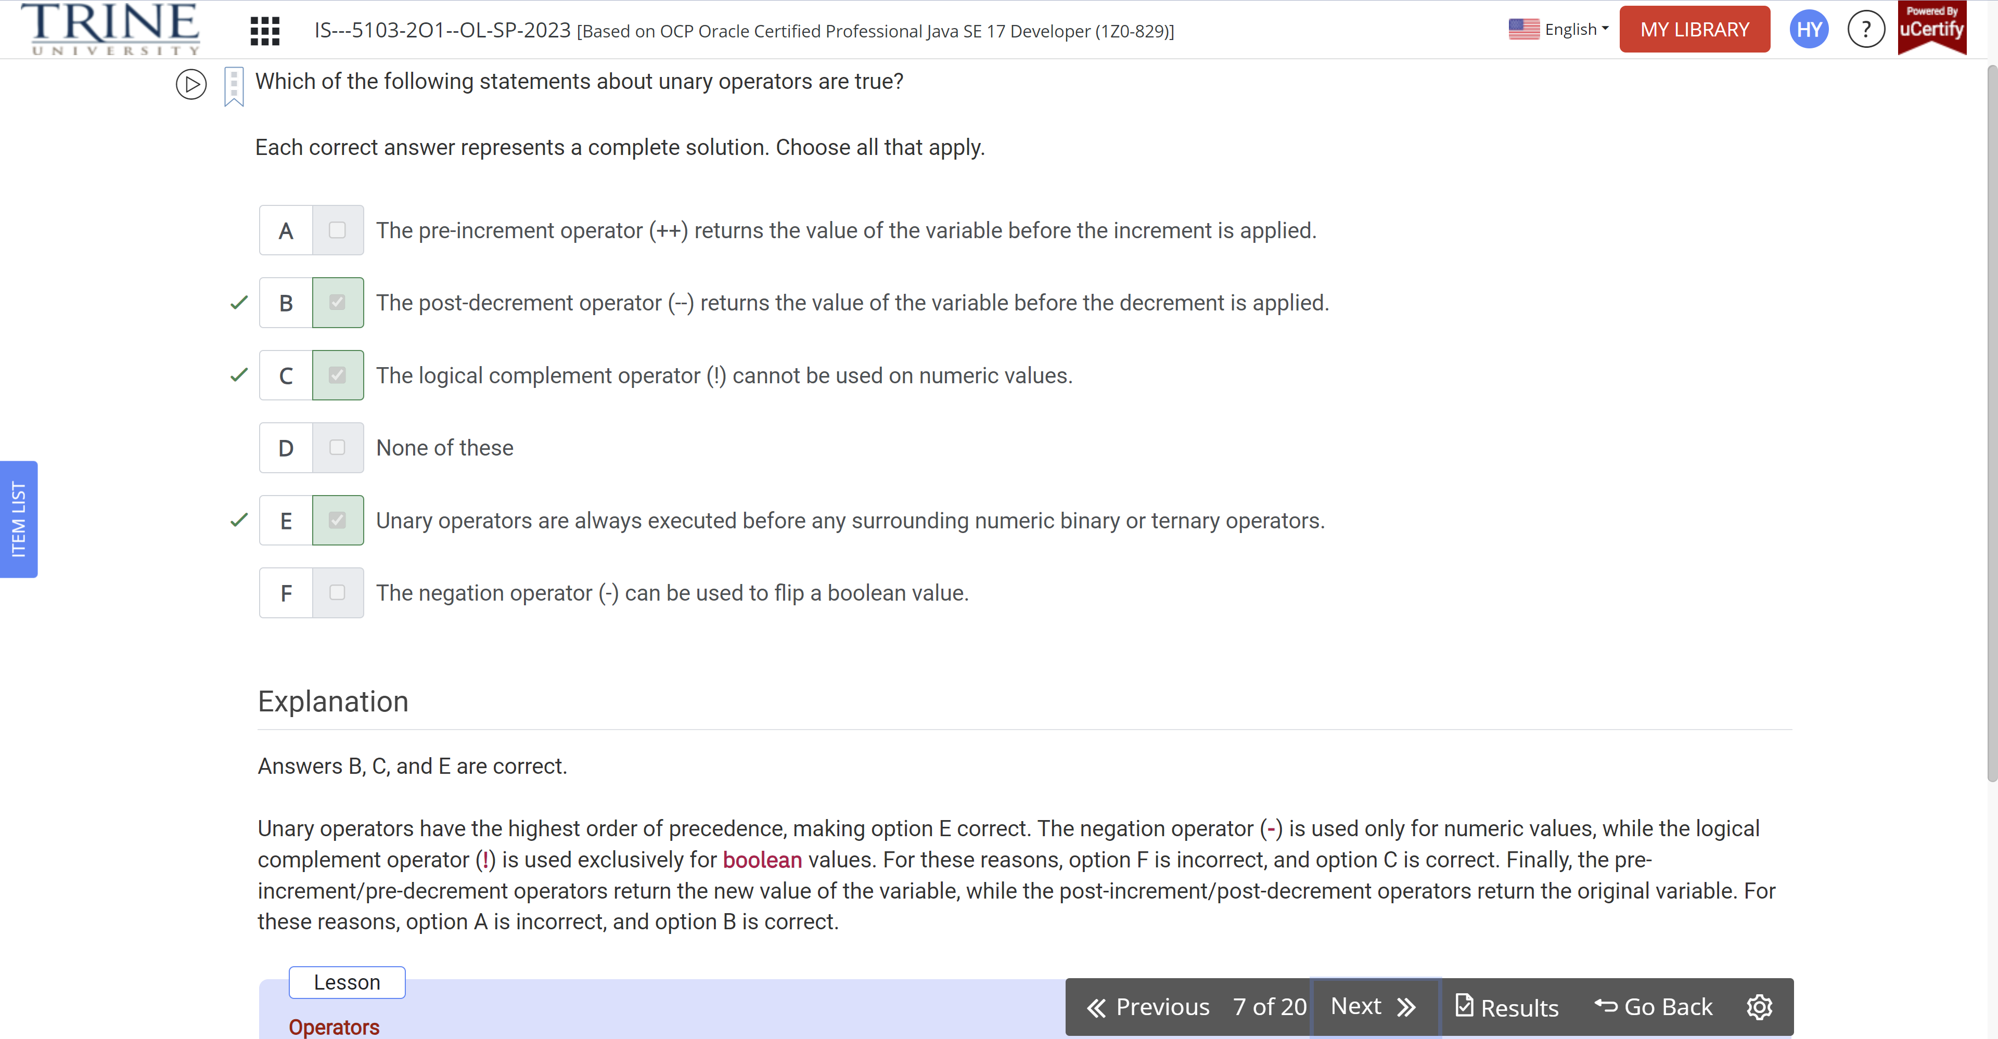

What is the result of executing the following code snippet?

Int myFavouriteNumber = 8;

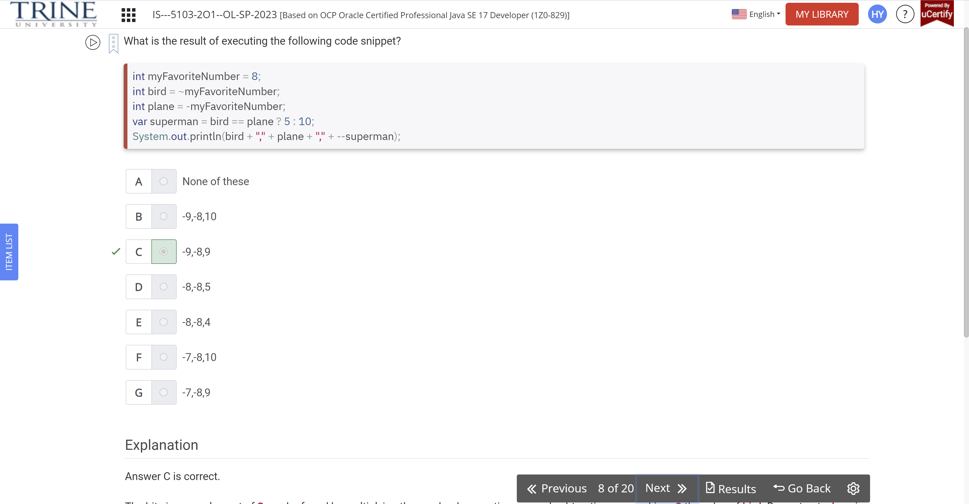

What is the unique output of the following code snippet?

Short height = 1, weight = 3;

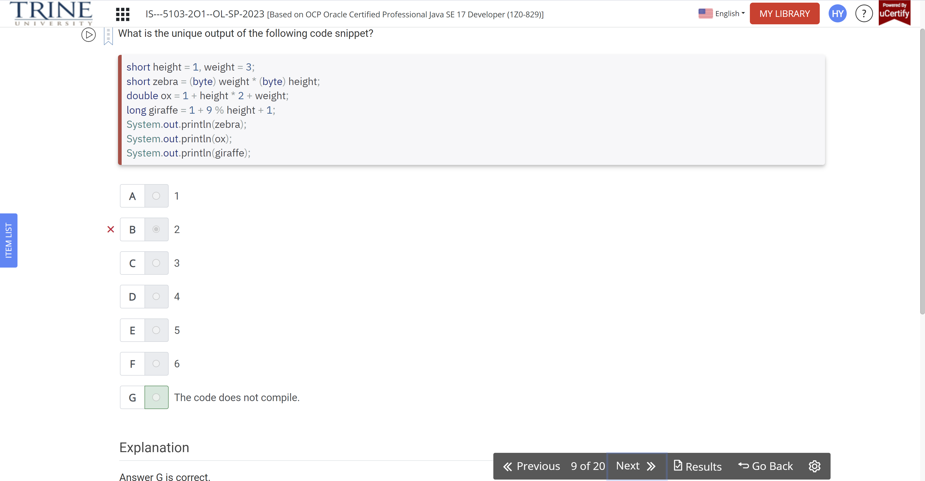

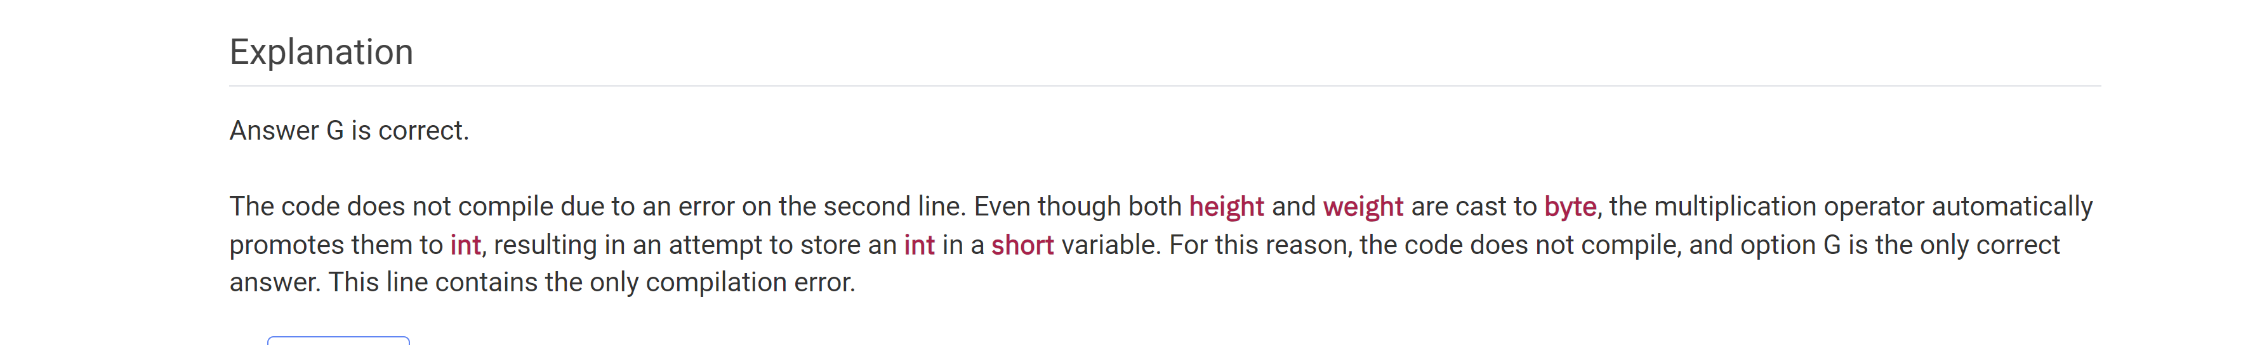

Which operator takes three operands or values?

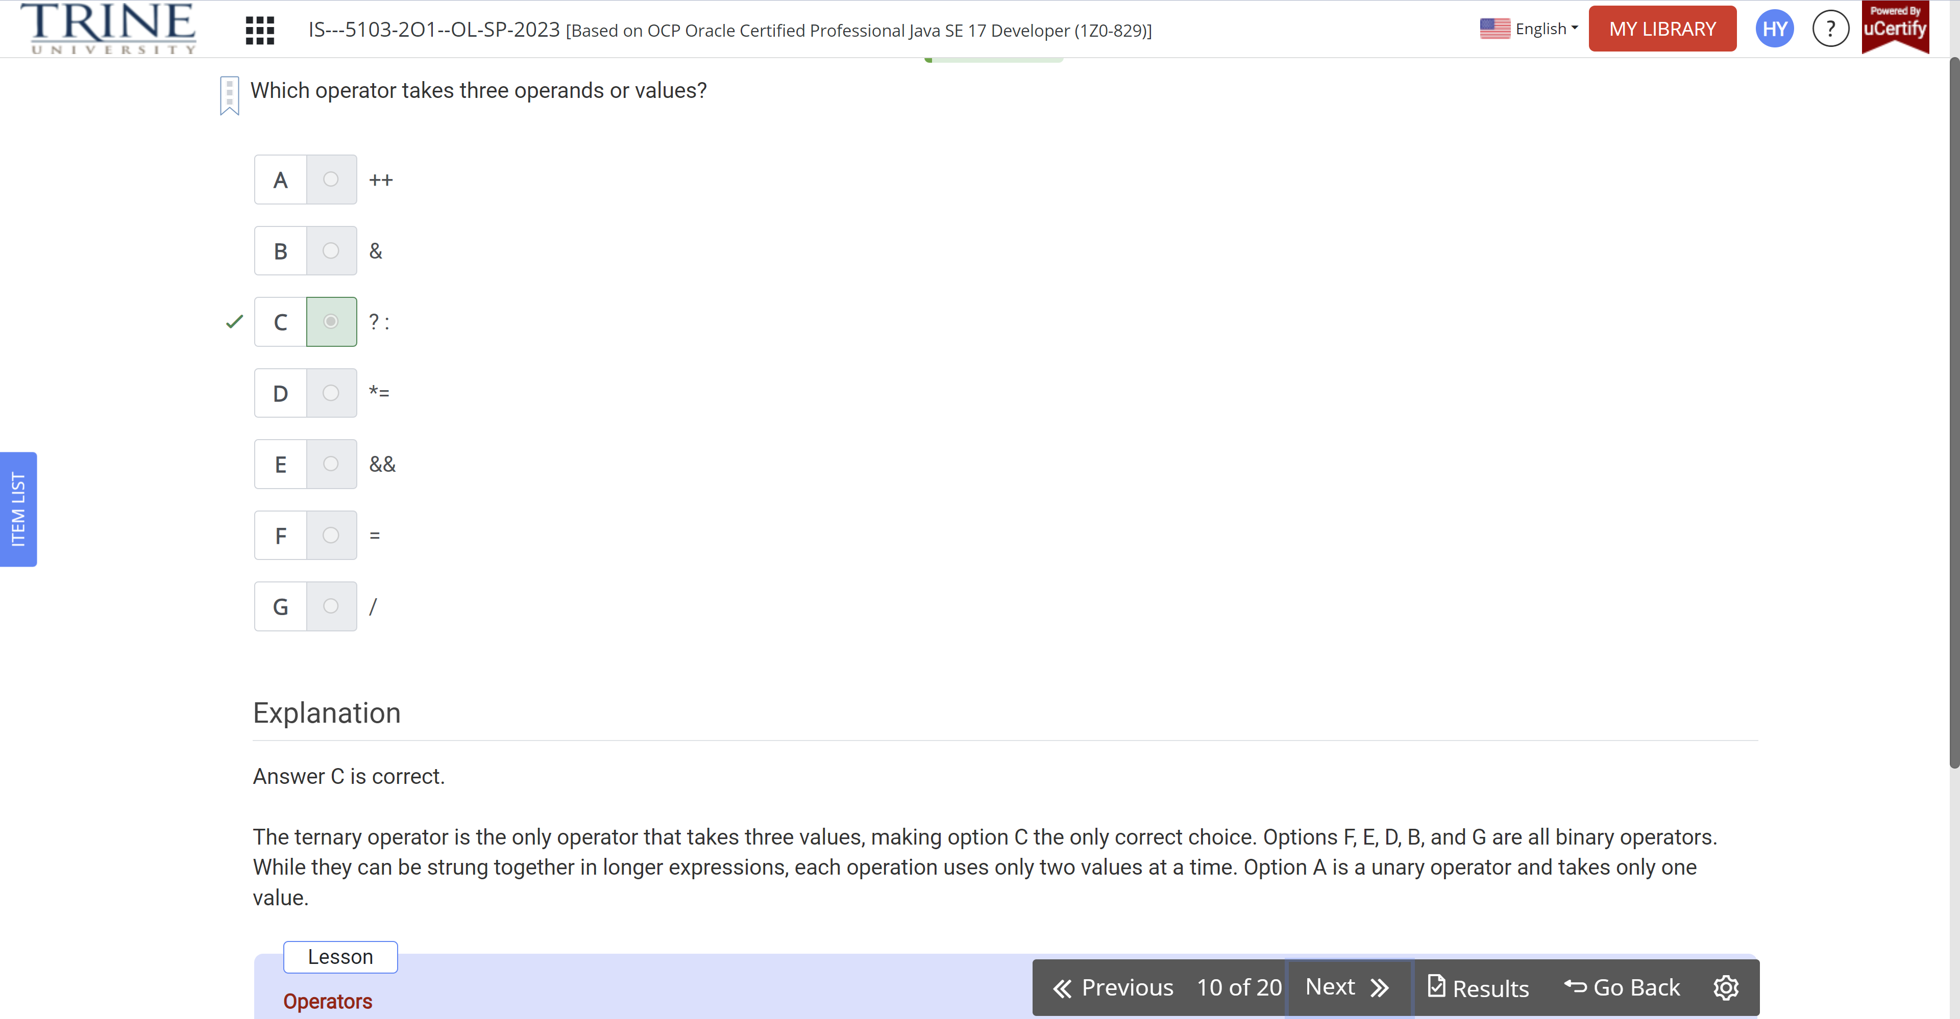

Which of the following can be used to change the order of operation in an expression?

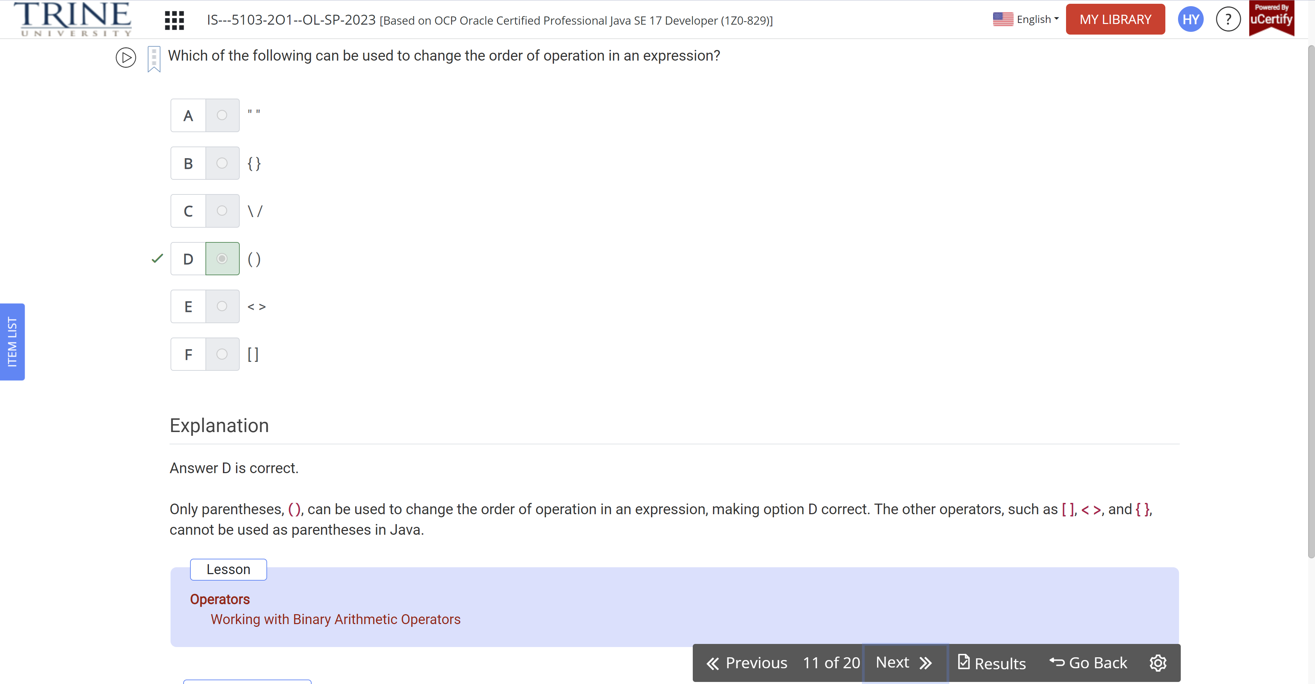

What is the output of the following code?

Int sample1=(2*4)%3;

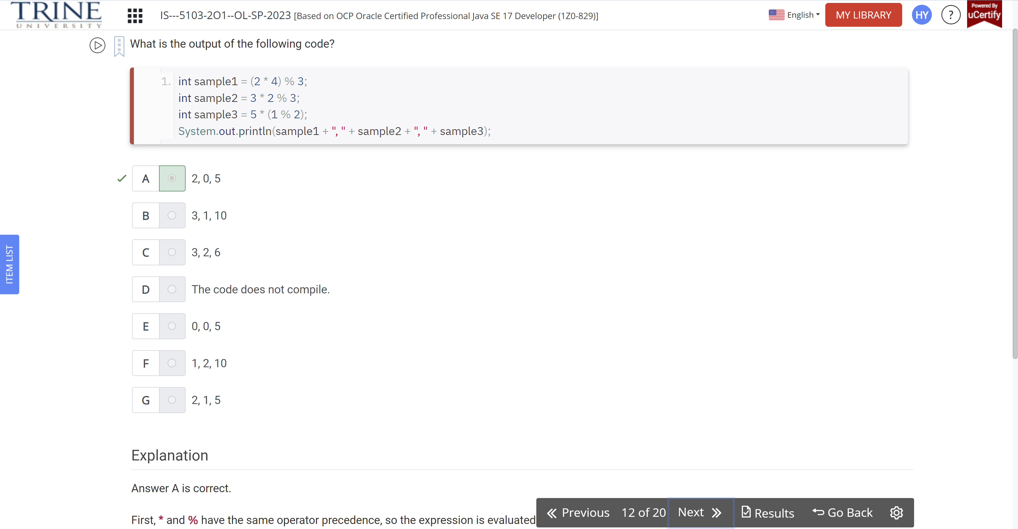

What is the output of the following code snippet?

Boolean sunny = true, …

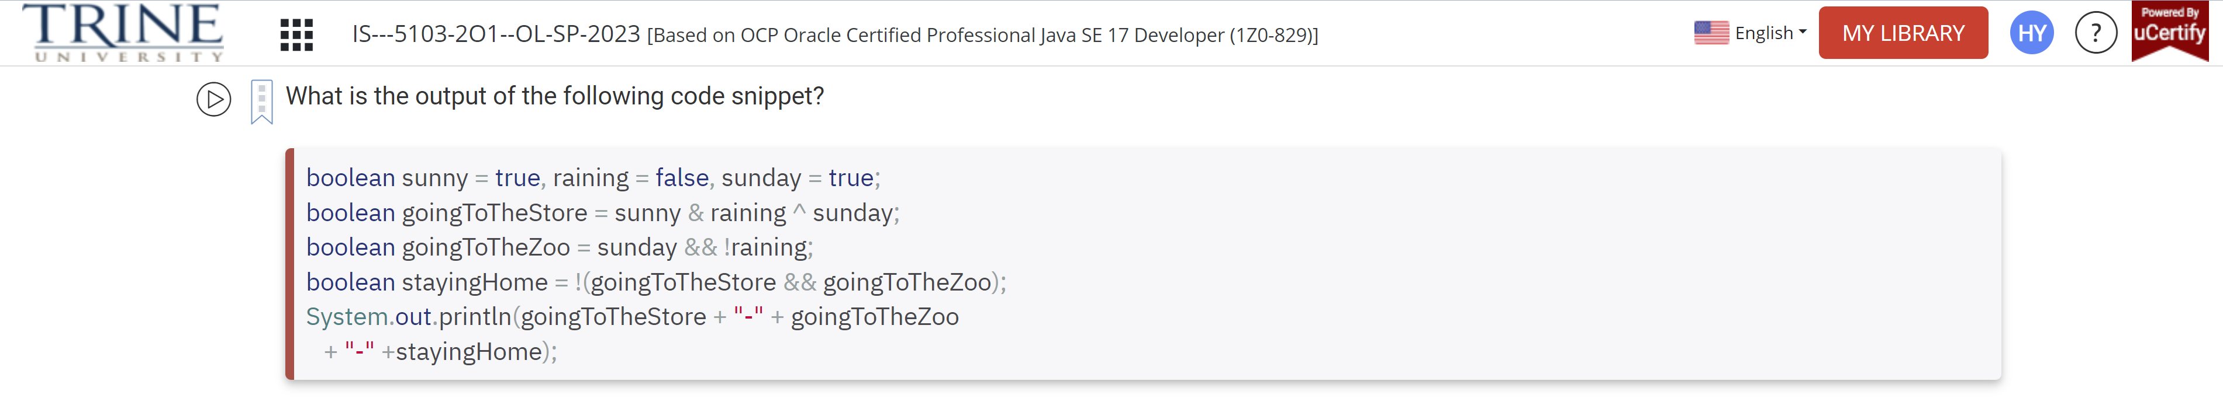

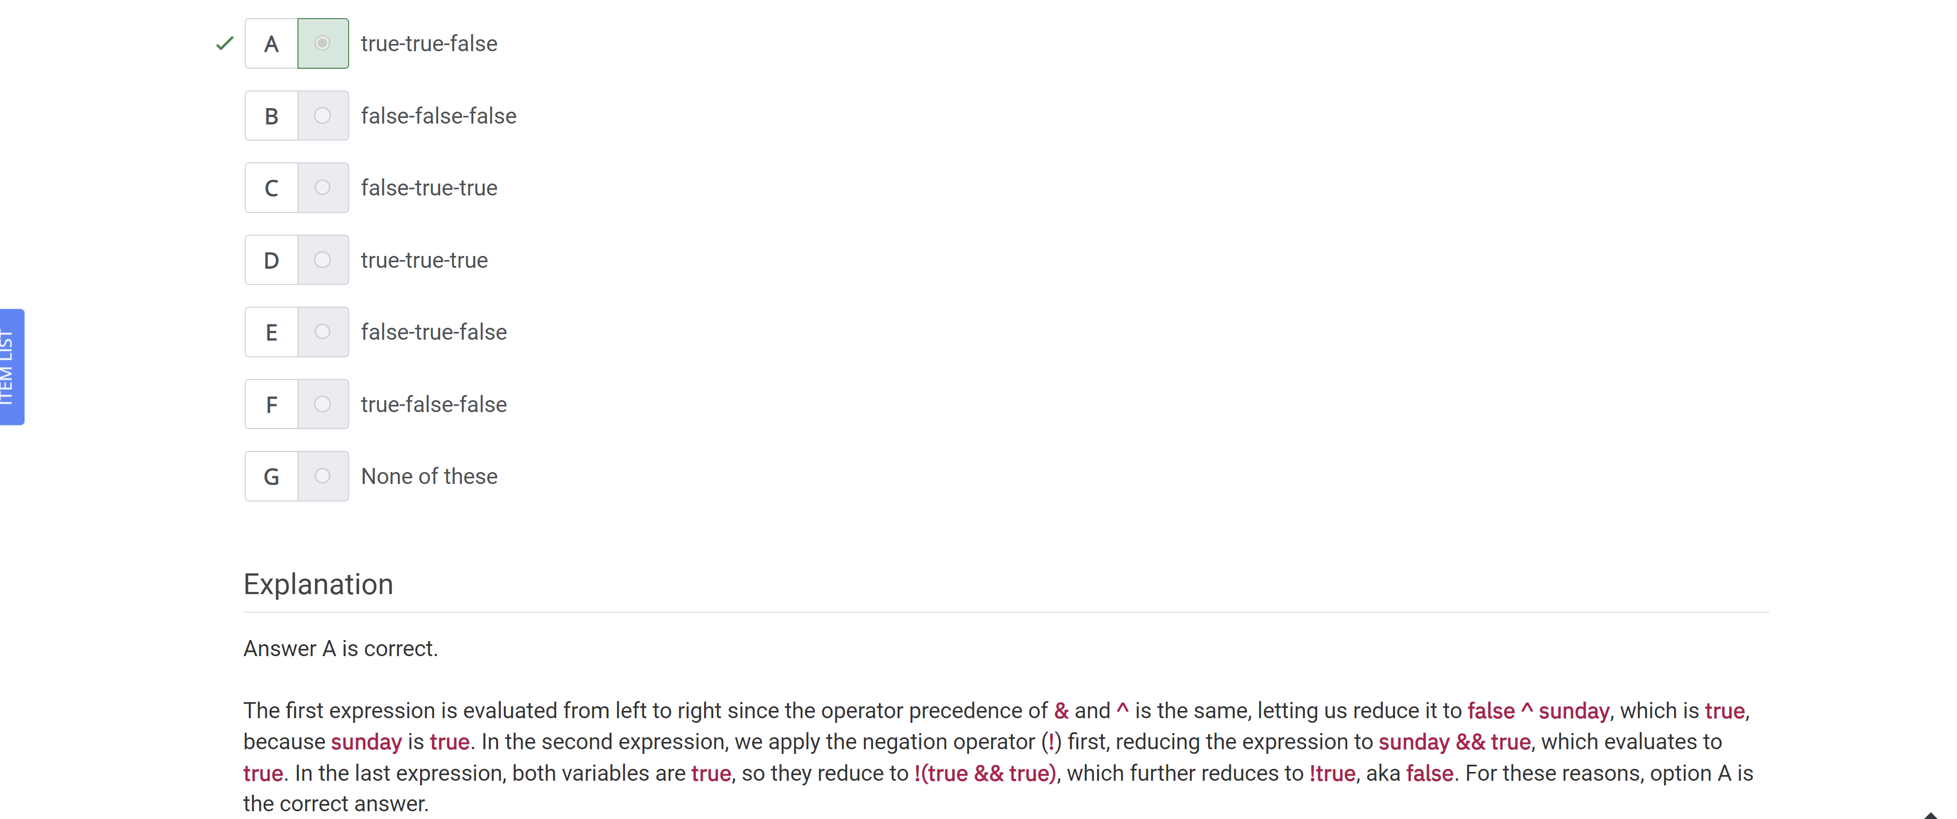

What is the output of the following program?

Public class CandyCounter {}

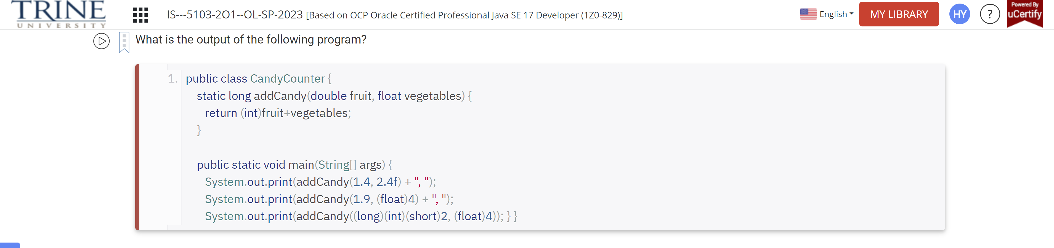

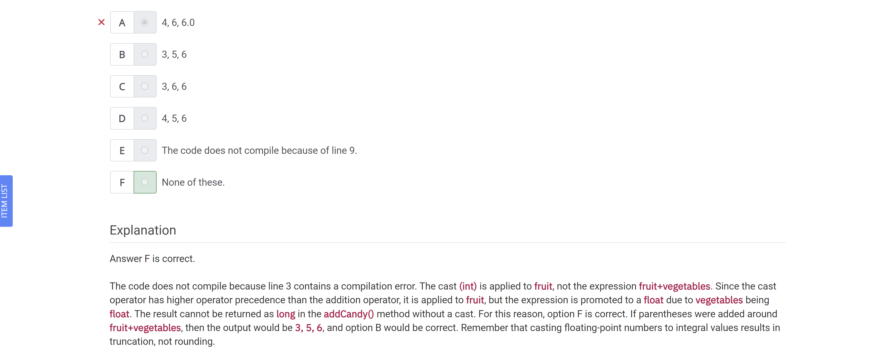

Which of the following operators are ranked in increasing or the same order of precedence? Assume the + operator is binary addition, not the unary form.

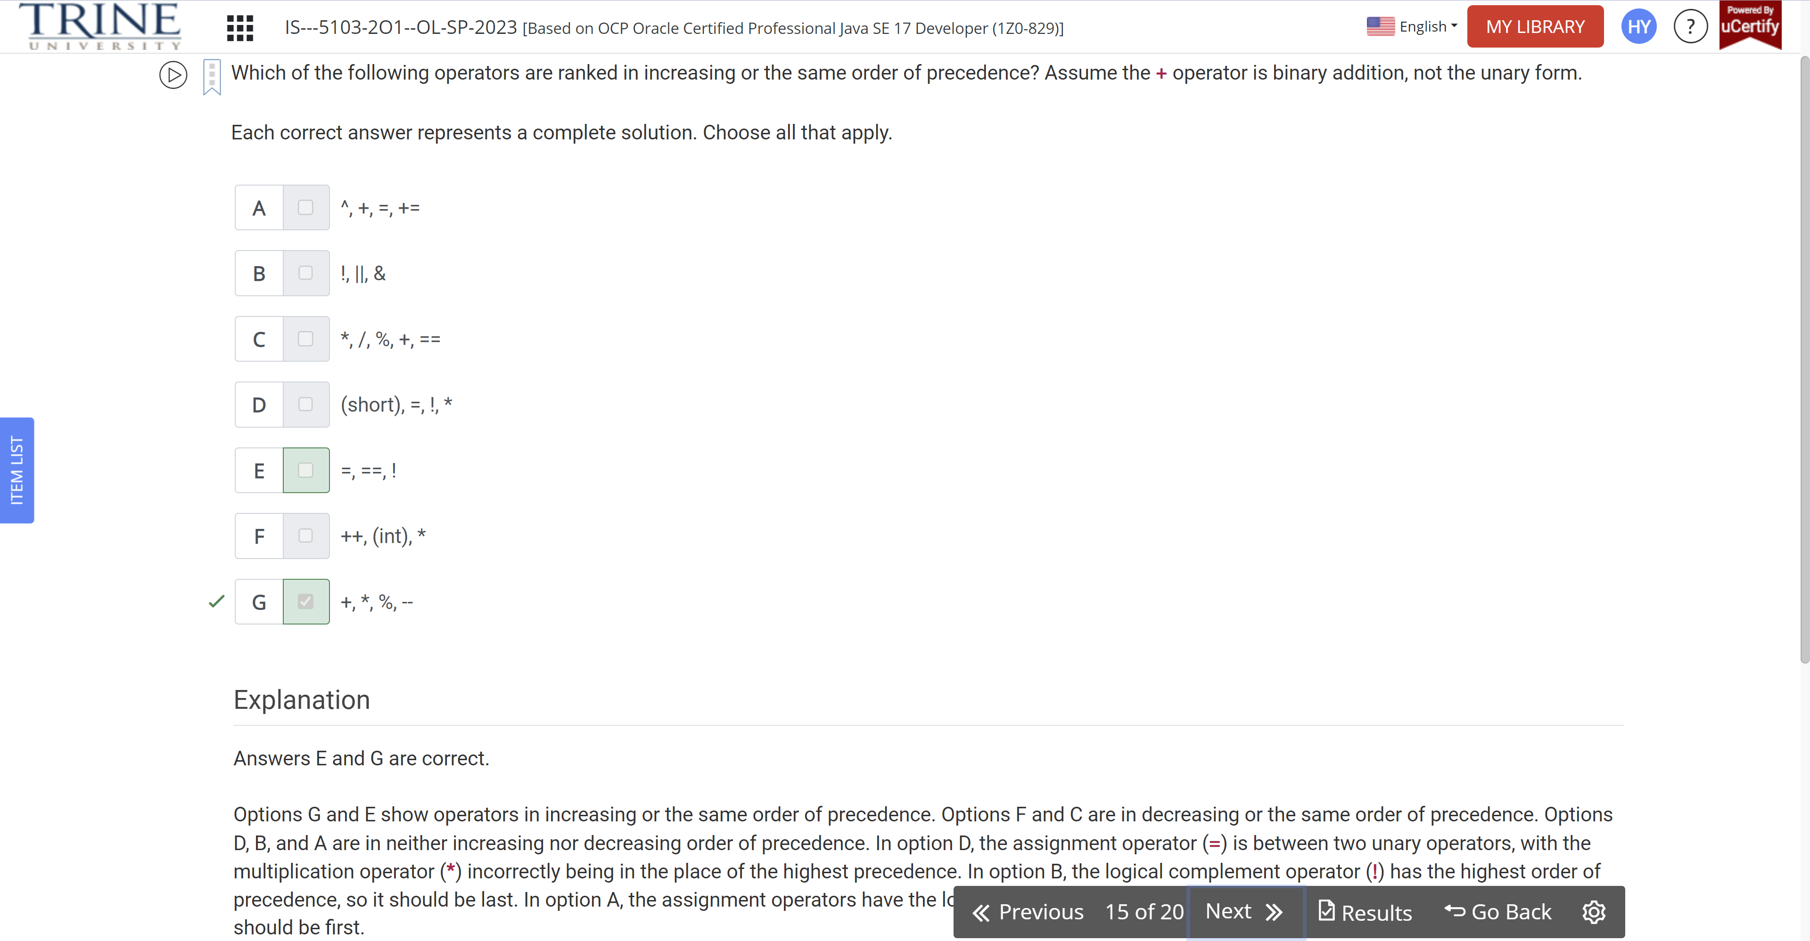

What change, when applied independently,…

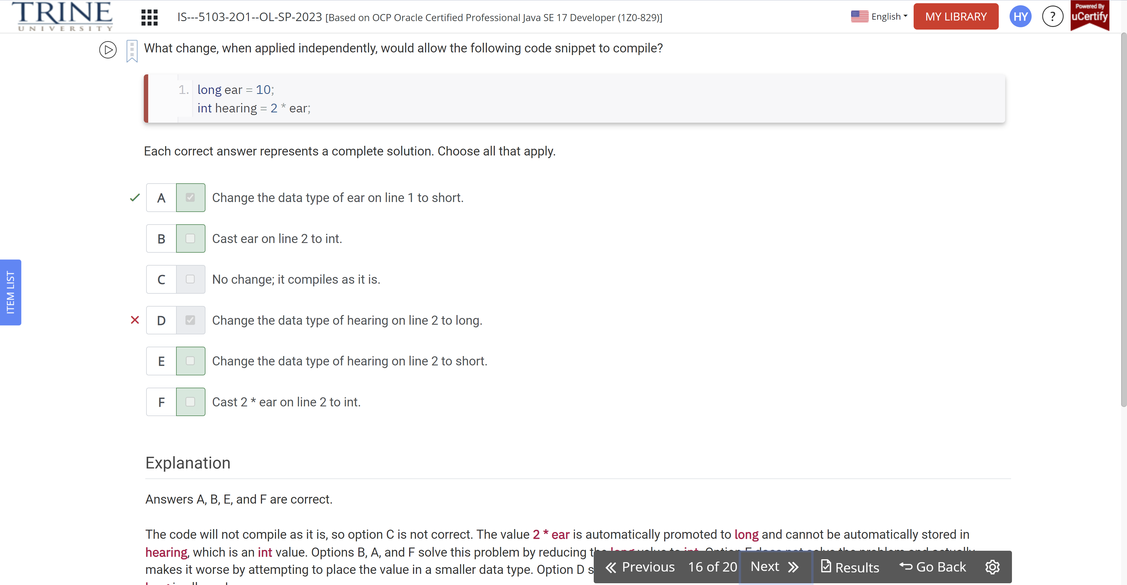

What is the result of executing the following code snippet?

Int start = 7

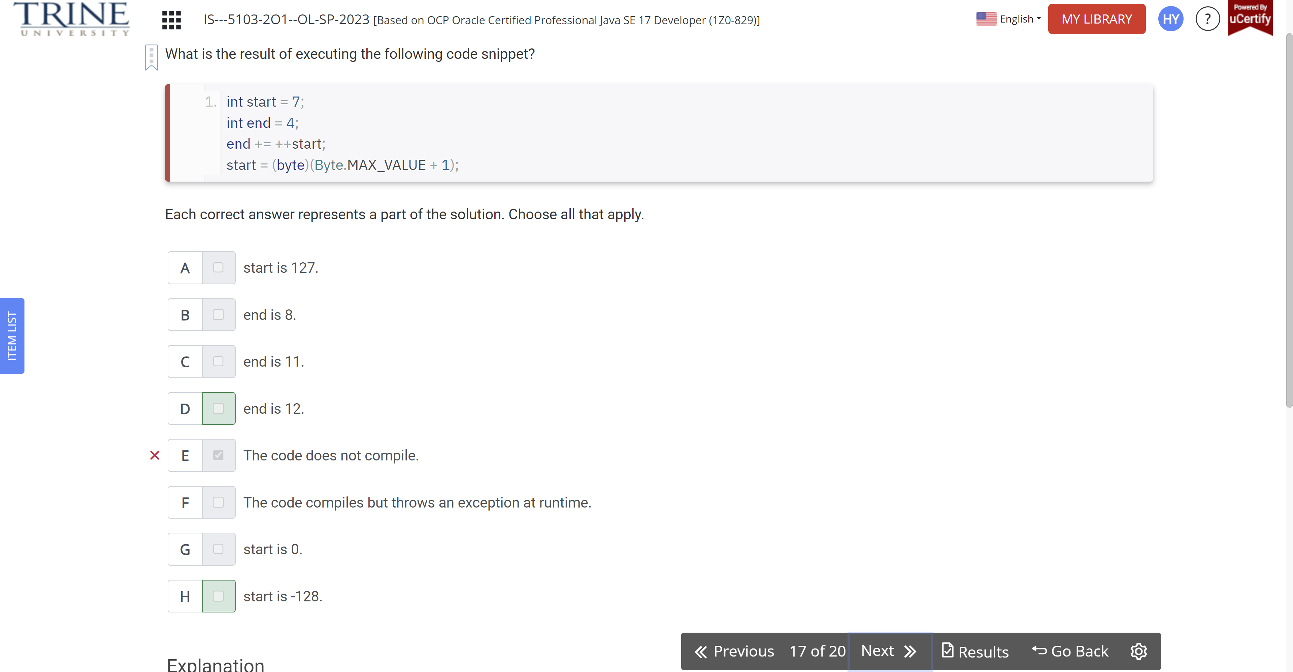

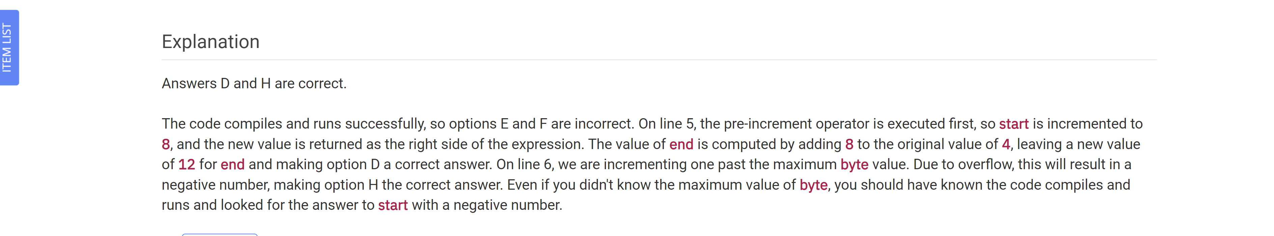

How many lines of following code contain compile errors?

Int note = 1 * 2…

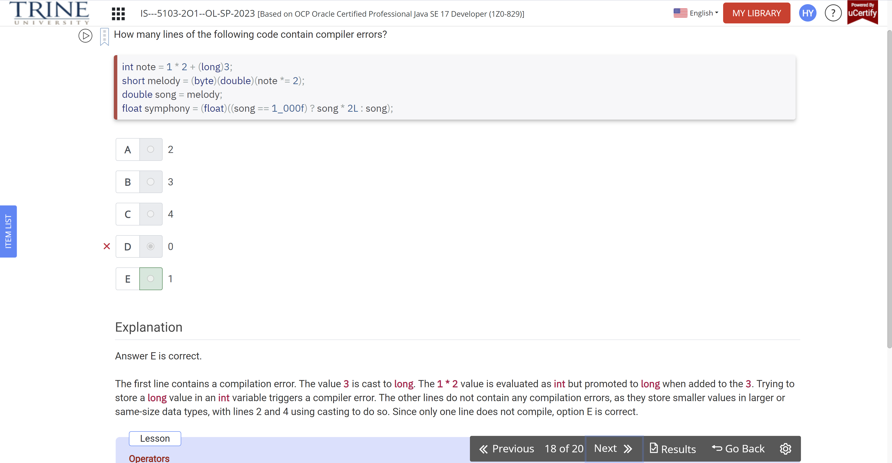

What is the output of the following code snippet?

Int pig = …

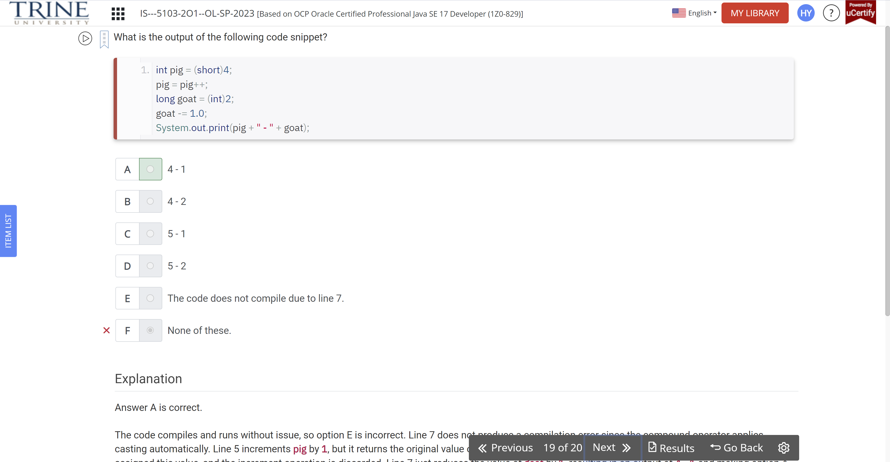

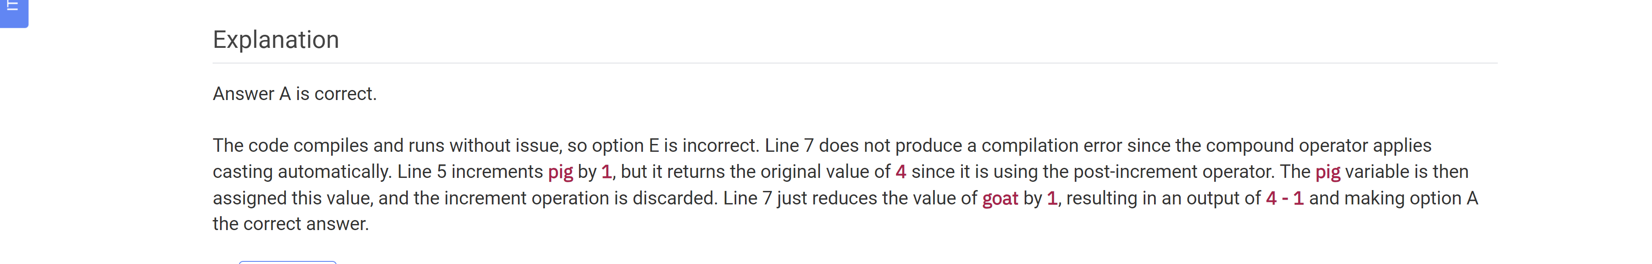

Which of the following statements are correct?

